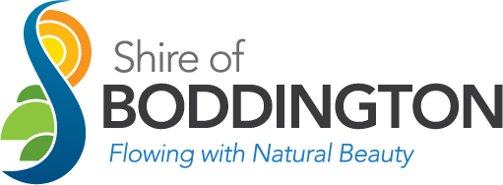

The Shire of Boddington is a values driven organisation proud to be serving our community with a diverse range of services. We are focused on working together, and delivering efficient and innovative ways of doing things.

The Shire is seeking a motivated individual to join our Corporate Services team. This position actively contributes to ensuring that the Shire’s governance processes and systems comply with legislative requirements, and also supports the team in embedding contemporary governance principles throughout the organisation.
The role is responsible for providing governance advice, coordinating policy, implementing integrated risk and governance frameworks and providing relevant reports. Key deliverables for this role are ongoing compliance activities, management of the Shire leasing portfolio and the preparation of integrated planning and reporting framework reports.
The successful candidate will have sound local government knowledge, experience in governance practices and legislative compliance, excellent customer service skills and advanced written and verbal communication skills. With outstanding administration skills and a keen eye for detail, you will have the ability to produce high quality work under pressure.
A competitive salary up to $79,020 per annum (pro rata) plus up to 16% superannuation, as well as access to other staff benefits including:
- flexible work arrangements including options to work from home
- housing allowance (up to $300 per fortnight)
- uniform allowance
- training and development opportunities

This is an excellent opportunity for someone looking for work/life balance, with the position offered on a flexible basis, up to 76 hours per fortnight.

An application package along with the position description can be obtained from www.boddington.wa.gov.au. For any further queries about the role, please contact Cara Ryan, Executive Manager Corporate Services on 9883 4999. For further information about the application process, contact Deb Lang on 9883 4999 or hr@boddington.wa.gov.au.

Applications are to be submitted to hr@boddington.wa.gov.au, and close at 4:00pm on Friday 12 August 2022.

