**Boddington, Marradong & Quindanning   
Cemetery Life Chronicle Submissions**

**FAQ & Information Sheet**

**What is Life Chronicle?**

Life Chronicle provides members of the public with an opportunity to create an online memorial to share stories of their loved one’s life, leaving an everlasting memory and eternal connection to their lives and legacy.

Life Chronicle creates a level of community engagement with the cemetery as they wander the grounds journeying through local history through stories shared by others. The memories of loved ones can be shared through their physical resting place and through an online memorial which can be accessed digitally.

**How do I submit a Life Chronicle story for my loved one?**

Life Chronicle submissions must be submitted by the Grant Holder of the plot, or in the case of a Grant holder being deceased, an immediate relative of the interned. If the Grant Holder is deceased, a Proof of Relationship form must be approved prior to submission. Forms can be obtained by contacting the Shire Office on 08 9883 4999.

**Is there a cost to make a Life Chronicle submission?**

Yes, each life Chronicle submission currently costs $65 paid directly to Chronicle. For each Life Chronicle payment, Chronicle will pay 40% back to the Shire of Boddington to contribute to the Boddington, Marradong and/or Quindanning Cemeteries, to help maintain the resting places of our loved ones.

**Life Chronicle stories can be submitted by following these steps:**

1. Visit the Shire of Boddington website cemetery page <https://www.boddington.wa.gov.au/connect/facilities/cemeteries.aspx>

2. Click on the Chronicle link to visit the Boddington, Marradong and Quindanning online platform.

3. Search and select the interned you want to write the Life Chronicle story for.

4. Click the “Write a Life Chronicle” button under the interment detail. Then, a popup window will appear.

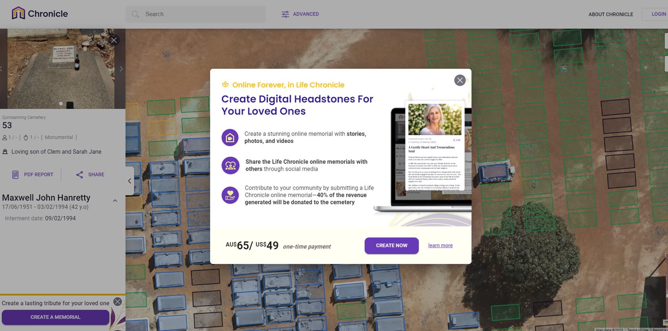

5. If there are multiple interments in one plot, please select the one you wish to write a story for. If there is only one interment in one plot, you will automatically be redirected to the next step.

6. Fill in your contact details and click the “Next” button to proceed (scroll down).

7. Type the life story that you want for the interment that you have selected. You can input links, bold, italic and underline the text if you want. You can also add maximum of 6 images for a Life Chronicle story.

8. Review your story to ensure that you have no typos and finalise your submission.

**How do I make the payment?**

1. Make sure you check the ‘Agree to terms and conditions’ tick box to proceed to the payment page.

2. Input your card details. Chronicle uses the secure Stripe service to process your payment.

3. When you payment is successful, you will receive a notification and an email confirmation which will include a payment invoice for the Life Chronicle that you have submitted.

**What happens next with my submission?**

Your Life Chronicle submission will be submitted to the Shire of Boddington for approval. Your submission will be checked for appropriateness and to confirm you are the grant holder / immediate family member of the interned. Once the Shire approves the submission, it will be immediately published publicly.

**How do I view my submission after it has been approved?**

Click on the Life Chronicle section under the interned detail on the left sidebar to view the full text in an expanded window. Then, a popup window will appear.

**What if my Life Chronicle submission is not approved?**

If the Shire of Boddington declines your submission, you will be notified via email and refunded in full. The reply email will include the reason it was declined. You are welcome and encouraged to resubmit the Life Chronicle again with any changes. Some reasons your Life Chronicle may be declined are inappropriate content, obscene language, or not being registered grant holder.