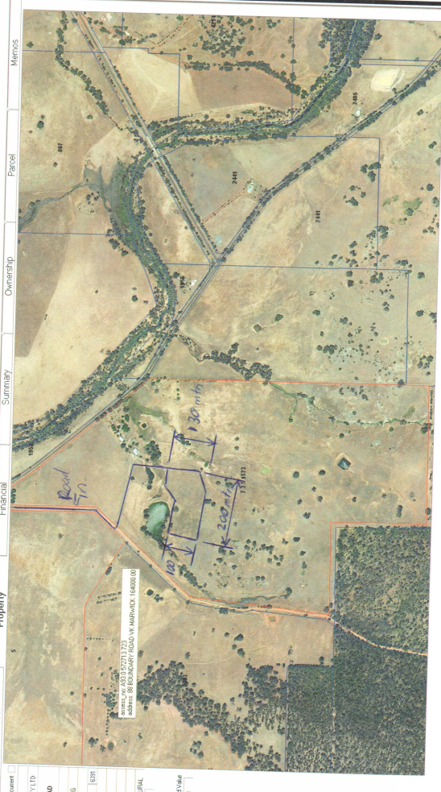
GRAVEL PIT
Lot 7 Harvey-Quindanning Road

