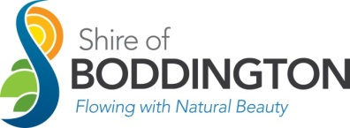
PERMIT TO CONSUME ALCOHOL ON SHIRE OF BODDINGTON PROPERTY
Organisation
Address for correspondence

NOMINATED INDIVIDUAL RESPONSIBLE FOR THE PERMIT OF CONSUME AND/OR SELL ALCOHOL
Name |  | Telephone
Address
Location of the function
Date of function | Start time |  |  | Finish time
Type of function |  |  | Expected Attendees

ALCOHOL
Method of Distribution | Supply |  | Sale |  | Bring Your Own
What type of drinks will be available?
Non Alcoholic |  | Low Alcoholic |  | Full Strength
Wine |  | Beer |  | Spirits
If selling alcohol, have you applied for a Liquor License? Yes No
Liquor License Number:
Have you liaised with local police in regards to your event? Yes No

SECURITY AND SAFETY
What security/safety measures will be undertaken to protect both Council property and members of the public?
Availability of Security Person | Yes | No
Restriction of alcohol to underage persons | Yes | No
Minimum of 1 Security Person per 100 guests | Yes | No
Adequate lighting around the bar and site | Yes | No
Adequate security around bar and site | Yes | No

FOOD
What type of food do you intend to make available
What times will food be available

I hereby make an application to consume alcohol at the above mentioned function
For office use only:

Approved Not Approved
Authorised Officer_____________________ Signature________________________ Date___________
Letter completed Yes
Date Sent ____________

_________________________ ______________________
Signature Date

